The Mathison Centre Research Grant (MRG)
March 2022 competition
(Terms of Reference)

Objective:
The Mathison Centre Open Research Grant Competition is to support innovative ideas that will advance research priorities of the centre. In line with our mission, projects must demonstrate that they are multi and or inter disciplinary by including members from at least two of the centre’s 3 pillars of research – Basic Sciences (Pillar 1), Clinical Sciences (Pillar 2) and Epidemiology & Population Health (Pillar 3).

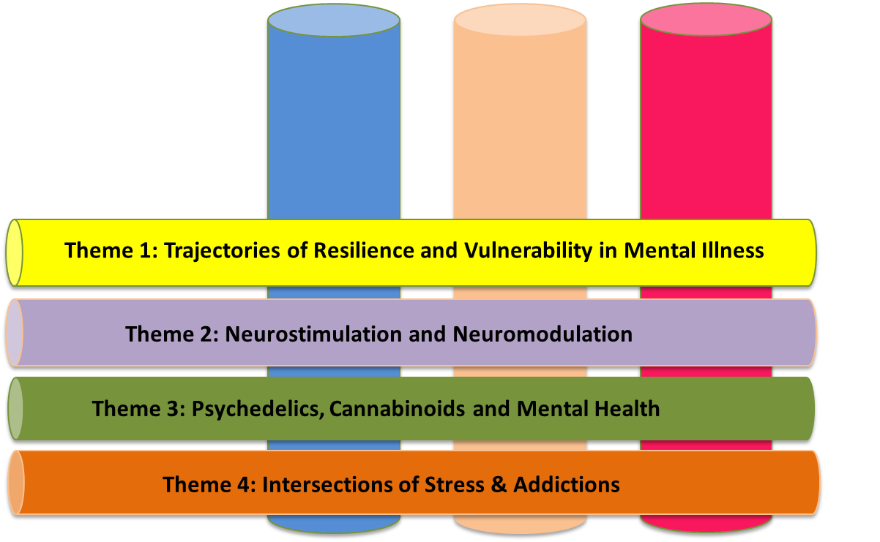
Pillar 1 Pillar 2 Pillar 3
Basic Clinical Epidemiology
Sciences Sciences & Population
Health

Eligibility criteria:
Principal Investigators must be a full member of the Mathison Centre. Only one application may be submitted per team. Team must include 2 or more applicants, from different disciplines.
Members who have held the MRG as PI and Co-PI are not eligible.

Use of funds
Eligible expenses include any aspects of the project (e.g., data collection, animal costs, graduate stipends, participant fees etc.). Funds may not be used for travel or as supplementary/top-up funding to an existing, pending or proposed project. All expenses must be justified.

Amount & Duration
One (1) award of up to $50,000. If the successful project requires less than $50,000, the remaining funds may be awarded to an eligible project in the competition. The award will provide a one-time payment to be spent by April 31, 2023. A one (1) year extension will be considered based on justification. Awards will be subject to ethical approval of the project if applicable.

Suitability of project and funding
- Briefly explain why this funding opportunity is most suitable for the project proposed (max. 1 paragraph)
- List any existing funds available to support the project. Indicate what costs the existing funds cover and how they differ from the costs to be incurred under this proposal.

Adjudication
Proposals will be judged based on the following criteria:
- Scientific merit 40%
- Alignment with research priority of the Mathison Centre 40%
- The team (multi and or interdisciplinary nature) 20%

Application
To apply, please submit the following to mathison.centre@ucalgary.ca by 5pm April 22, 2022. Your application must include the following:
- Research Proposal (no more than 2 pages long)
- Justification of team and alignment to research priority (no more than 1 page)
- Budget (1 page only)
- CVs for each PI (no more than 2 pages long per PI)

