Mathison Centre for Mental Health Research & Education Summer Studentships

This award honours the commitment of the donors to the training of future leaders in mental health research by providing studentships to summer students.

Donors: | Ronald P. Mathison
Eligibility: | Open to students registered full-time in an undergraduate program at any university worldwide who will undertake summer research in the field of mental health. Only one applicant per supervisor/lab is eligible for funding each year. Preference will be given to candidates who applied for other sources of summer studentship funding.
Value: | The award is tenable for a minimum of 3 months, and a maximum of 4 months during the period of May to August.  The stipend is $1,000 per month to a maximum of $4,000 per student per year.
Supervisors Responsibility: | Due to limited resources, the Mathison Centre Summer Studentship program will not be able to fund all summer studentship applications. If a student is not awarded a Mathison Summer Studentship, the supervisor is encouraged to provide the required funding.
Where Tenable: | University of Calgary
Citizenship: | Unrestricted
Nomination Process: | Awards will be adjudicated by the leadership team of the Mathison Centre
Apply: | Candidates must submit transcripts, application form with project description, and supervisor letter of support as one single PDF file to: mathison.centre@ucalgary.ca
Deadline: | March 10th

Mathison Centre for Mental Health Research & Education Summer Studentship Application

Student Information Please complete and return this form along with transcripts, and supervisor letter of support.
UCID# Email: Name:

Last Name First Name Initial(s)

Telephone: - - Date of Birth: - -
Area Code Month Year
What other scholarship programs you have Please attach copies of the first page of each
applied to? application.

NSERC
If other, please specify:
USRP AI PURE Other

Work Term 3 months (June, July, August) 4 Months (May, June, July, August)
Proposed start date: |  |  | End Date:
Day | Month | Year | Day | Month | Year
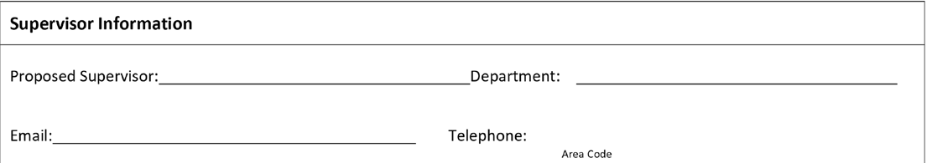

Student Signature Date

Supervisor Signature
Date
_ _

Please provide a brief research project description below (~250 words)

